 | 12.1.50 Editors - Geometry Nodes Editor - Header - Add Menu - Utilities - Matrix
Table of content
Detailed table of content 1
Add menu - Utilities - Matrix 3
Combine Matrix 3
Combine Transform 4
Matrix Determinant 4
Invert Matrix 5
Multiply Matrix 5
Project Point 5
Separate Matrix 6
Separate Transform 6
Transform Direction 7
Transform Point 7
Transpose Matrix 8

Detailed table of content
Detailed table of content
Detailed table of content 1
Add menu - Utilities - Matrix 3
Combine Matrix 3
Inputs 3
Column 1 , 2, 3, 4 3
Output 3
Matrix 3
Combine Transform 4
Inputs 4
Translation 4
Rotation 4
Scale 4
Output 4
Transform 4
Matrix Determinant 4
Inputs 4
Matgrix 4
Output 4
Determinant 4
Invert Matrix 5
Inputs 5
Matrix 5
Output 5
Matrix 5
Invertible 5
Multiply Matrix 5
Inputs 5
Matrix, Matrix 5
Output 5
Matrix 5
Project Point 5
Inputs 5
Vector 5
Transform 5
Output 6
Vector 6
Separate Matrix 6
Inputs 6
Matrix 6
Output 6
Column 1 , 2, 3, 4 6
Separate Transform 6
Inputs 6
Transform 6
Output 6
Translation 6
Rotation 7
Scale 7
Transform Direction 7
Inputs 7
Direction 7
Transform 7
Output 7
Direction 7
Transform Point 7
Inputs 7
Vector 7
Transform 7
Output 7
Direction 7
Transpose Matrix 8
Inputs 8
Matrix 8
Output 8
Matrix 8

Add menu - Utilities - Matrix
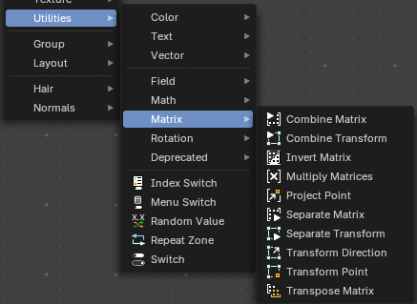
Matrix nodes.

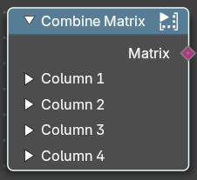
Combine Matrix
Combines values into a matrix. A matrix is something like a transform cage. A vector 4 in 4 dimensions.

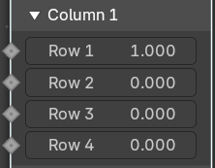
Inputs

Column 1 , 2, 3, 4
Allows you to combine values into the matrix. A matrix is made of four vector 4 in 4 dimensions. So 16 values.

Output

Matrix
The output matrix.

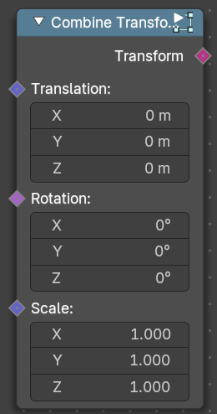
Combine Transform
Combines transforms.

Inputs

Translation
The translation input vector.

Rotation
The rotation input vector.

Scale
The scale input vector.

Output

Transform
The output transform.

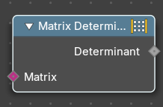
Matrix Determinant
The Matrix Determinant Node is used for calculating the determinant of a given matrix. Use this node to evaluate whether a matrix has properties for invertibility, scaling, and orientation.

Inputs

Matgrix
Accepts a matrix input.

Output

Determinant
Returns a single numerical value representing the determinant of the input matrix. If the determinant is zero, the matrix is non-invertible.

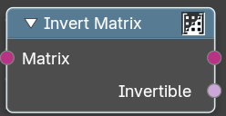
Invert Matrix
Inverts the matrix values.

Inputs

Matrix
The input matrix.

Output

Matrix
The output matrix.

Invertible
The inverted values.

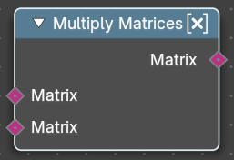
Multiply Matrix
Multiplies the values of two matrices.

Inputs

Matrix, Matrix
The input matrices

Output

Matrix
The output matrix.

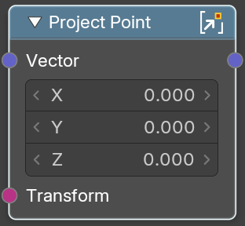
Project Point
Projects a transform point by a vector.

Inputs

Vector
The input vector

Transform
The input transform point

Output

Vector
The output vector.

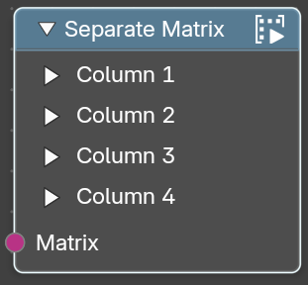
Separate Matrix
Extract single values from a matrix. A matrix is something like a transform cage. A vector 4 in 4 dimensions.

Inputs

Matrix
The input matrix.

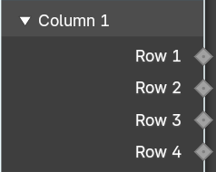
Output

Column 1 , 2, 3, 4
Extract the values from a row in a column. A matrix is made of four vector 4 in 4 dimensions. So 16 values.

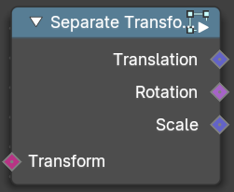
Separate Transform
Extracts the translation, rotation or scale values from a transform.

Inputs

Transform
The input transform.

Output

Translation
The translation output vector.

Rotation
The rotation output vector.

Scale
The scale output vector.

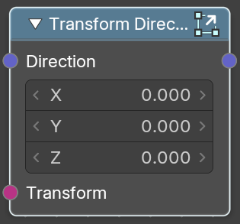
Transform Direction
Set the direction of a transform.

Inputs

Direction
The input vector 3.

Transform
The input transform.

Output

Direction
The output direction.

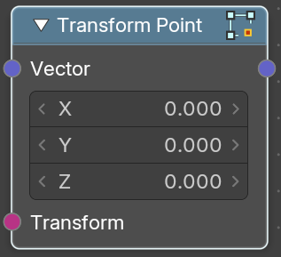
Transform Point
Transform a transform point.

Inputs

Vector
The input vector 3.

Transform
The input transform.

Output

Direction
The output vector.

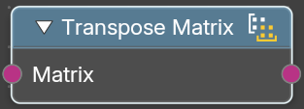
Transpose Matrix
Retreive the transpose matrix from a matrix.

Inputs

Matrix
The input matrix.

Output

Matrix
The output transpose matrix.

